11/29/2014

Martin Zuber

B00066378

Modern Web

Literature Review

Contents

Abstract 2

Platforms: Mobile devices are on the move 3

Browsers: Many knights, but no king 3

Sources: More content is coming from third parties 5

What developers think? 5

Conclusion 6

Table of Figures 7

References 7

## Abstract

Today’s web is more complicated than ever. Web content is delivered to desktops, laptops, mobile devices, game consoles, and smart televisions. Each has a different screen size, performance capabilities and additional features. Web content is delivered in the form of dynamic web pages and feature rich applications in an environment without a common standard in web browsers. In addition to that, internet usage reaching billions online with all the human diversity additional complexity can be problematic. This paper purpose is to review some studies and white papers that address these problems. The research done in this field is immense and produced many solutions in the form of frameworks, tooltips, plugins, design patterns and methodologies and it’s out of the scope of this paper to cover all of those. I tried to name only general challenges in this review. Therefore I chose three white papers to study with additional research of relevant articles on the web. My work was driven by the need to acquire better understanding of concurrent state of the web, the web development challenges and methodologies. In conclusion I can claim that this paper delivers just that. It does not provide any specific solutions, but general recommendations.

## Platforms: Mobile devices are on the move

Each month an increasing number of people are switching from PCs to tablets and mobile devices to browse the internet and by 2015 they’ll be using those more than any other device. Mobile traffic grew 120% between Q2 2013 and Q2 2014 while desktop traffic remained flat (monetate.com, 2014).

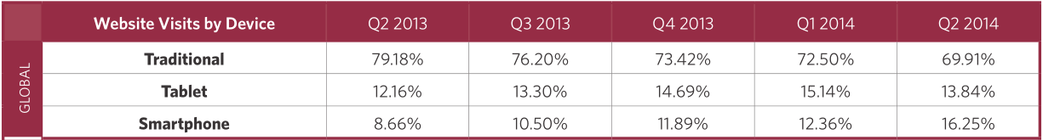

Figure IBM Analytics Benchmark

From a development point of view certain areas on a website may function differently or may not function at all on mobile or tablet devices.

**Some of the issues are:**

* No Flash support
* Popups stops a website to being used on a small screen
* Tiny text links unusable on the touch screen
* Website elements overlapping on the small screen
* And many more…

Screen size and performance restrictions are the main reasons for design reevaluation of the application design. Web developers are using separate mobile pages, responsive web design and business apps to ensure a good user experience regardless of device type.

## Browsers: Many knights, but no king

In the past, nobody questioned which browser ruled the land – it was Microsoft’s Internet Explorer. According to the latest analysis of the Web browsers, situation is very different now. Web browser market share varies from platform to platform.

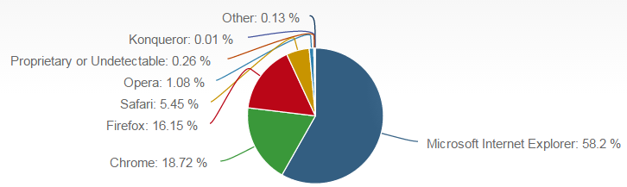

Figure Desktop Browsers

Microsoft still wins desktop market with 58.2% share has acknowledged being critically late to mobile where his presence is almost negligible with 2.21% share. This led to domination of Webkit-based browsers: Safari, Chrome and Android with Apple’s Safari being the leader with 48.91% share.

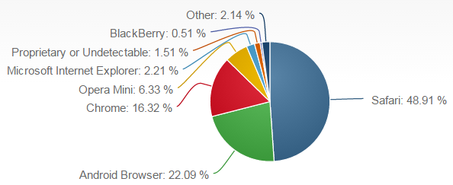

Figure Moblle Browsers

Situation in console market is very different with most of the market shares in hands of proprietary browsers embedded in a particular device. Only Opera is getting a 4.51% share as a result of Nintendo implementing Opera browser in some of their consoles. (Technologies, 2014).

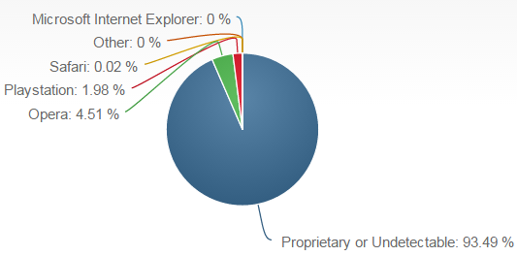

Figure Console Browsers

It’s great that internet users have so many browser options. Unfortunately developers must put a lot of work into making sure that websites are compatible with as many browsers as possible.

**Here are some of the most common browser compatibility issues (Herken, 2014):**

* Elements not correctly positioned
* Browser specific CSS styles
* Lack of Valid HTML/CSS
* Javascript processing times
* Frames related problems

There is a vast research done to tackle these issues and many useful practices, methodologies, frameworks and tooltips have arisen in recent years. Technologies like HTML5 and CSS3 are making cross-browser problems more manageable and web developers are getting less concerned about browser compatibility issues (Jonson, 2014).

## Sources: More content is coming from third parties

Third-party content is a term that covers a lot of ground, from advertising to guest blog posts.

**The term frequently include:**

* Content delivery networks (CDNs)
* Advertising
* Web analytics
* Social Media
* Microblogs
* Miscellaneous Widgets

Analysis shows that the average web transaction involves 8.59 different third parties or hosts. (Gomez, 2010). These web page components are dragging down the overall performance of the website. Various research was done to illustrate the impact that third-party additions have on web site performance. Some of the third-party widgets can impact a site’s performance by as much as 30% (keynote.com, 2014). In spite of these findings third-party components are virtually indispensable to many web sites today, whether they bring in revenue through advertising, or drive business by bringing in new users through social media. To tackle performance issues the best option includes continuous performance monitoring of the web site to pinpoint the components with the worst impact.

## What developers think?

Recent study (Kartik Bajaj, 2013) took a different approach to name modern web challenges. They tried to find out what are the issues that web developers are discussing among themselves. To do so, they examined over 500,000 questions asked on <http://www.stackoverflow.com> over a four year period (2009-2013).

**Here are the big takeaways from their analysis:**

* Javascript is still most popular topic, but HTML5 and CSS is raising
* Cross-browser compatibility still big, but declining
* New HTML5 and Javascript features questions are raising
* Web technologies are growing in importance in mobile development

## Conclusion

Modern web is a complex and lively medium. New technologies arise on daily bases. Users are connecting to web with various devices through different browsers. Webpages of today are dynamic applications with third party content interconnecting different domains. With all these fast paced changes, the contemporary web developers are facing many new and difficult challenges. Evolving and researching never stops in the life of web designers and developers. New frameworks, toolkits, methodologies are created to tackle major issues and improve web development productivity. Some of the examples of prominent frameworks are Bootstrap, Grails, jQuery, Node.js (devrates.com, n.d.).

The user doesn’t care about all these technical issues. He wants to browse his web sites from laptop, mobile phone or game console. He expects a web page to perform quickly and properly every time and on every device. He wants to share content or buy a product by touching a widget. All this is possible on today’s Web.

## Table of Figures

* Figure is showing IBM Analytics Benchmark of devices requesting IBM web pages.
* Figure 1 is showing Desktop Browsers market share
* Figure 2 is showing Mobile Browsers market share
* Figure 3 is showing Console Browsers market share

# References

devrates.com, n.d. *devrates projects list.* [Online]   
Available at: http://devrates.com/project/list

Gomez, 2010. *Thriving in a multi-browser world.* [Online]   
Available at: http://www.cio.com.au/campaign/370042?content=%2Fwhitepaper%2F370263%2Fthriving-in-a-multi-browser-world-ensuring-optimal-website-performance-for-all-end-users%2F%3Ftype%3Dother%26arg%3D0%26location%3Dfeatured_list  
[Accessed 21 11 2014].

Herken, D., 2014. *5 Most Common Browser Compatibility Issues.* [Online]   
Available at: http://www.browseemall.com/Articles/post/2014/04/24/5-Most-Common-Browser-Compatibility-Issues.aspx  
[Accessed 29 11 2014].

Jonson, P., 2014. *Web developers less concerned about browser-compatibility, more concerned with HTML5.* [Online]   
Available at: http://www.itworld.com/article/2693441/big-data/web-developers-less-concerned-about-browser-compatibility--more-concerned-with-html5.html  
[Accessed 25 11 2014].

Kartik Bajaj, K. P. A. M., 2013. *Mining Questions Asked by Web Developers.* [Online]   
Available at: http://salt.ece.ubc.ca/publications/docs/kartik-msr14.pdf  
[Accessed 15 11 2014].

keynote.com, 2014. *The Benefits of Third-Party Content Monitoring.* [Online]   
Available at: http://www.keynote.com/resources/white-papers/benefits-of-3rd-party-content-monitoring  
[Accessed 23 11 2014].

monetate.com, 2014. *Ecommerce Quarterly EQ2 2014.* [Online]   
Available at: http://www.monetate.com/research/#ufh-i-25962265-ecommerce-quarterly-eq2-2014

Technologies, M. S. S. f. I., 2014. *Browser market share 2014.* [Online]   
Available at: http://www.netmarketshare.com/browser-market-share.aspx?qprid=0&qptimeframe=Y&qpcustomb=&qpcustomd=2  
[Accessed 30 11 2014].